**TEST REPORT – 13.10.2023** [**https://www.pothys.com/**](https://www.pothys.com/)

**Tailoring Option Issues:**

1, If options are not selected and stitch button is clicked, no alert message is popping up on the screen. It should be display something like “Kindly select any of the options above”.

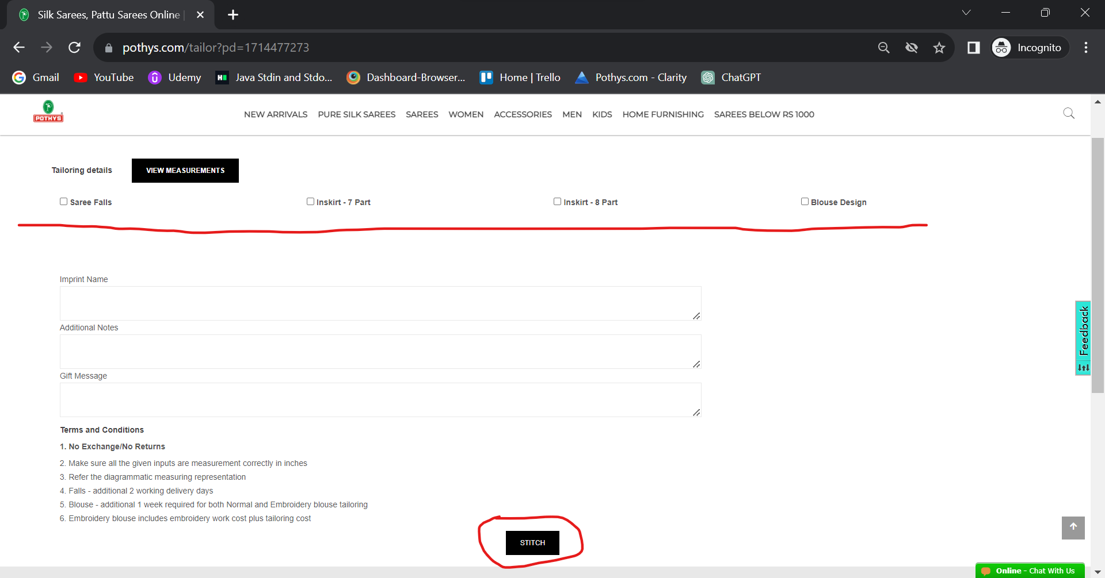

**Mobile UI:**

If we click stitch without selecting any options, “successfully added” message is displaying.

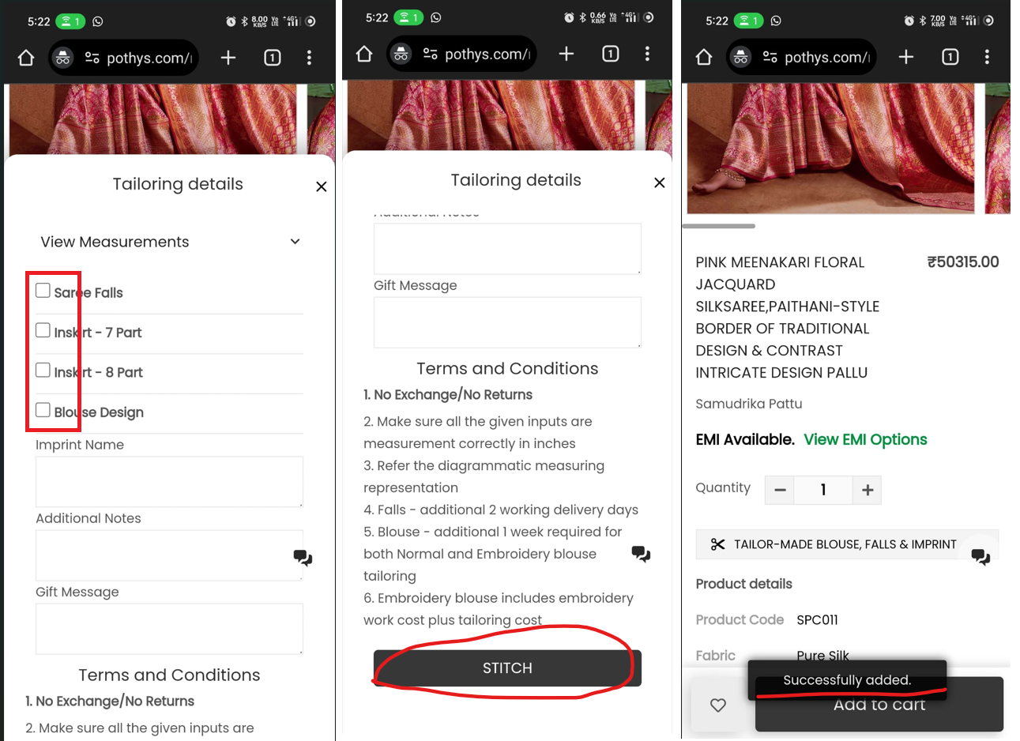

2, Blouse preview image is broken

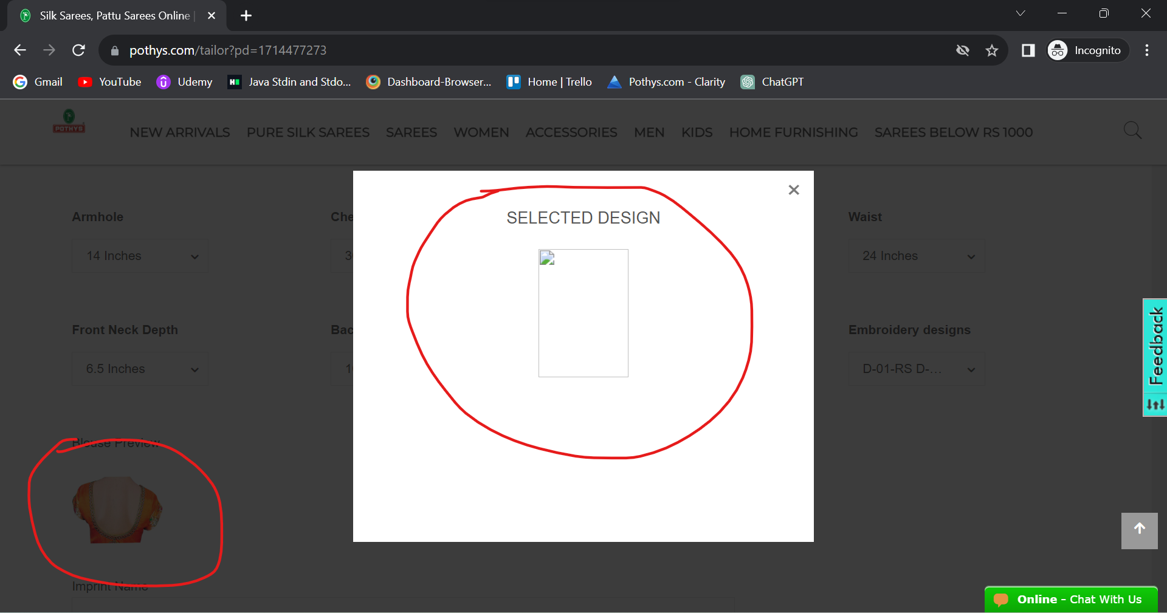

3, Apart from the **silk sarees**, any other saree category not having the measurement selecting options for blouse design

